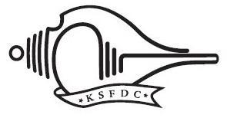

KERALA STATE FILM DEVELOPMENT CORPORATION LTD.

No. 2544/D1/23/KSFDC 10.04.2025
INVITATION FOR QUOTATIONS Publicity Design for Upcoming KSFDC Film
Sealed quotations are invited from reputed publicity design firms or individual professionals for the publicity design of an upcoming film produced by the Kerala State Film Development Corporation (KSFDC).
Eligibility Criteria

Applicants must have a minimum experience of executing publicity design work for at least 12 feature films released within the last 5 years.
Scope of Work / Design Deliverables
The selected firm/professional will be required to create the following publicity materials:
- • 30” x 40” poster designs – 5 Nos
- • 6-sheet hoarding designs – 4 Nos
- • Promotional digital designs (for social media, online platforms, etc.) – 15 Nos

All designs must align with the creative brief provided by KSFDC and adhere to professional standards suitable for both print and digital media.Bid Submission Requirements

Interested firms/professionals are required to submit a sealed quotation containing the following:
a) Detailed Profile of the firm/professional, outlining relevant qualifications and expertise b) List of Feature Films for which publicity design work was undertaken, clearly indicating the release dates c) Proposed Fee Structure for the assignment, inclusive of all listed deliverables
Submission Deadline extended :

The sealed quotation should reach the KSFDC Head Office on or before 23rd April 2025.

Sd/-
Administrative Officer

